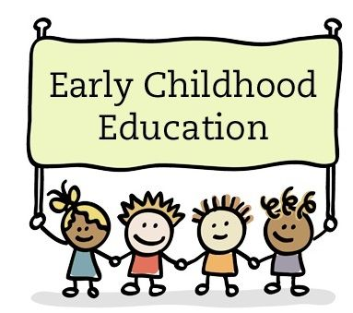

Early Childhood Questionnaire

We need your feedback! Moving forward, we are considering introducing a 3 year old program – to work with our current Pre-Kindergarten program.

So that we can look at this realistically & logistically, please fill out the questionnaire and return it to the school asap.

1. Do you have a child who will be 4 in the fall that you plan to enroll? __________
Yes or No

2. Do you have a child who will be 3 in the fall that you would enroll if we had this program? ________________
Yes or No

3. Do you know someone who would seriously consider enrolling their child in our 3 year program, if we had one? _____________
Yes or No

Name___________________________________________

Thank you!

